**Build Management**

Build Management is the process of assembling all the components of a software application into an installable software product. This process usually includes the following steps: The Preparing the Build Environment. The Gathering of the Source Code. The Labeling of the Source Code.

In the simple term we can say that build management is a process of creating EAR file that we can deploy/execute from Application server.

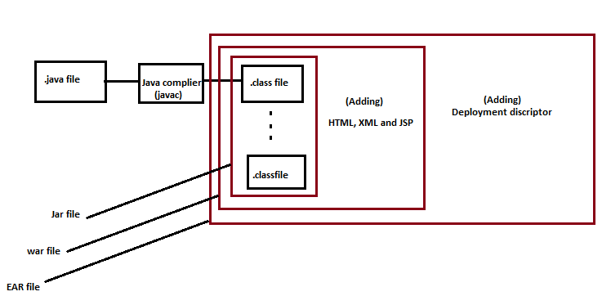

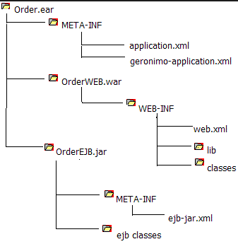

|  |  |
| --- | --- |
| Topic | Description |
| Jar file | Collection of .class file is called jar file. |
| War file | Jar file along with JSP, HTML and xml file called war file. |
| EAR file | war file along with deployment descriptor is called EAR file. |

We can automate EAR creation process with the help of ANT (Another nice tool) script with the help of build.xml file.

|  |  |
| --- | --- |
| Topic | Description |
| Copy tag | it copy the file from given location. |
| Replace tag | it replace a string into file with a new value. |

<replace file="${src}/index.html" token="@@@" value="wombat"/>

<copy todir="../backup/dir" <fileset dir="src_dir"/> <globmapper from="*" to="*.bak"/> </copy>

**Deployment descriptor**

A **deployment descriptor** provides description of application that required by container to identify server side resources.

**Source Code repository**- It is a place where we stored our code.

**Service Management**- Managing 3P.(People, process and policy)

**Incident Management**- any interruption of IT services is called incident.

**Problem management** – Identifying the Root Couse of incident and closing with a fix, so we may not again have problem again.

Operation management- managing OPS activity.